|  |  |
| --- | --- |
| Test Name | UC05 Confirming Loans |
| Use Case Tested: | Confirming Loans |
| Test Description: | Tests when a borrower has selected and completed their loan choices that they are able to confirm their pending loans and complete the borrowing process. |
| Pre-conditions | The program is on the “Confirm Loans” panel.  The borrower has a list of pending loans on screen. |
| Post-conditions | System shows the Main Menu.  Loans appear on the Printer. |
| Notes: |  |

|  |  |  |
| --- | --- | --- |
| Data 1 Attempt | |  |
| Result (Pass/Fail/Warning/Incomplete) | Fail | |

|  |  |  |  |  |
| --- | --- | --- | --- | --- |
|  | TEST STEP | EXPECTED TEST RESULTS | P | F |
|  | Borrower presses the “Confirm” button on the “Confirm Loans” panel. | System shows the Main Menu. |  | F |
|  |  | Loans appear on the Printer. |  | F |

Note: The page stayed on the “Confirm Loans” panel, and only one of the loans printed.

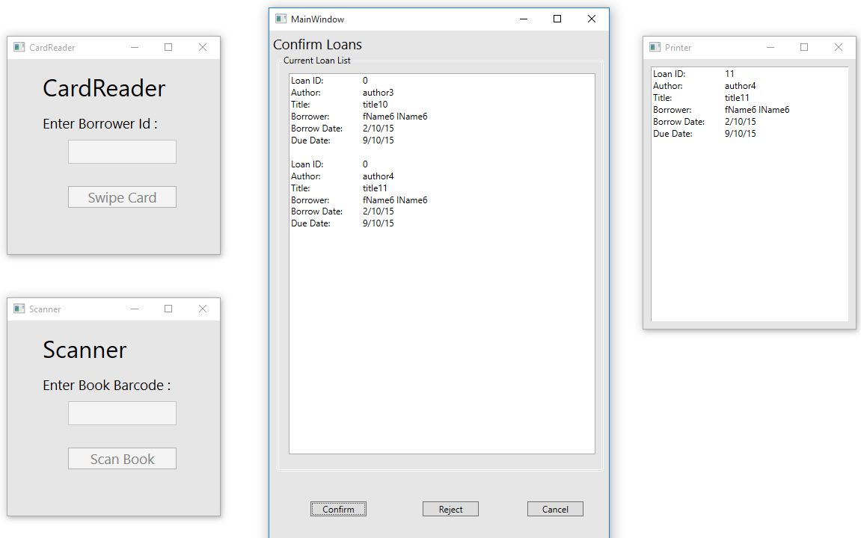

|  |  |  |  |  |  |
| --- | --- | --- | --- | --- | --- |
| Test Data Table | | | | | |
|  | **Member** | **Book** | **3** | **4** | **5** |
| Data 1 Attempt | 6 | 10 |  |  |  |
|  |  | 11 |  |  |  |
|  |  |  | Complete |  |  |
|  |  |  | Confirm |  |  |